INDUCTION MATERIAL
  - Diocese of Waikato & Taranaki
Version 1, March 2021

Induction Material
An Introduction to the Diocese of
Waikato and Taranaki
Version 1

“A Family in God who are followers of Christ”
Contents
Geography 1
Archdeaconries and Ministry Units 3
Parininihi Archdeaconry 3
Piako Archdeaconry 3
Maungatautari Archdeaconry 3
Waikato Archdeaconry 3
Waitomo Archdeaconry 3
Waitotara Archdeaconry 3
Diocesan Vision 3
Diocesan Leadership 4
Communication 4
Diocesan 4
Mission 5
Education and Formation 5
Vocation 5
Administration and Expectations 6
Statutes 6
Clergy 6
Ministry Standards 6
Synod 6
Shared Life 6
Payroll, Pension scheme, Insurance and Moving Expenses 7
Contact Details 7

Geography
The Diocese of Waikato and Taranaki stretches from Waverley and Waitotara in southern Taranaki, to Te Kauwhata south of the Bombay hills, across to Whangamata in the north east, and back through Matamata and Mangakino to where we began. There are 51 ministry units and six archdeaconries.
In addition, we have two social service agencies:
- The Bishop’s Action Foundation known as BAF (CEO, Simon Cayley, based in New Plymouth)
- Anglican Action (CEO, Karen Morrison-Hume, based in Hamilton)
Also, five church schools:
- Waikato Diocesan School for Girls (Hamilton)
- Taranaki Diocesan School for Girls (Stratford)
- Southwell School (Hamilton)
- St Paul’s Collegiate (Hamilton)
- St Peter’s School Cambridge
Beyond this, we are represented in assorted tertiary institutions, resthomes, and prisons.
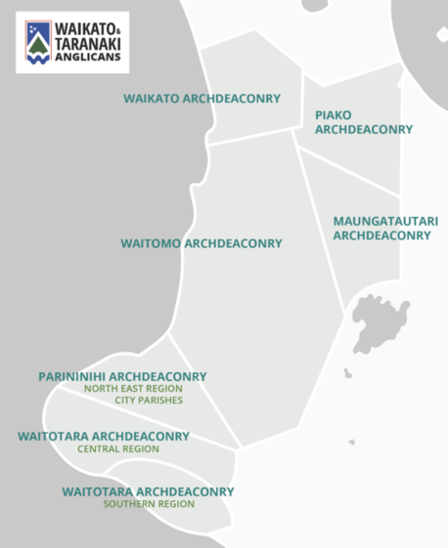

Archdeaconries and Ministry Units

Parininihi Archdeaconry
Bell Block, Brooklands, Inglewood, Fitzroy, Okato/Oakura, Taranaki Cathedral of St Mary New Plymouth, West New Plymouth, and Waitara

Piako Archdeaconry
Katikati, Matamata, Morrinsville, Paeroa, Te Aroha, Waihi, Waihi Beach, Whangamata

Maungatautari Archdeaconry
Cambridge, Mangakino, Putaruru, Tamahere, Tirau, Tokoroa, St Peter's School Cambridge

Waikato Archdeaconry
Bryant Park, Chartwell, Claudelands, Melville, Hillcrest, Nawton, St James East Hamilton, St George's and St David's Frankton, Forest Lake, St Peter's Cathedral, Gordonton, Huntly, Ngaruawahia, Raglan, Te Kauwhata, St Paul's Collegiate, Waikato Diocesan School for Girls, University of Waikato Ecumenical Chaplain, Southwell School

Waitomo Archdeaconry
Kawhia, Orakau, Otorohanga, Piopio Aria Mokau, Taumarunui, Te Awamutu, Te Kuiti

Waitotara Archdeaconry
Eltham, St Mary's Hawera, Wesley Hawera, Kaponga Co-op, Manaia, Opunake, St George's Patea, St Luke's Co-op Patea, Stratford, Waverley/Waitotara

Diocesan Vision
Each year at Synod, the Bishop shares his vision for the Diocese. You can read more about this vision online: https://www.wtanglican.nz/vision/
At the heart of this vision is the aspirational phrase: We seek to be a family in God who are followers of Christ. This drives all that we aim to do as the body of Christ living out the ministry that we share in. We believe this can be achieved by prioritising these three values:
- Marked by Gratitude – Ngākau Whakawhetai
- Growing Disciples – Tupuranga Ākonga
- Transforming Communities – Whakaahua Hapori
Those values will manifest in:
- Our response to urban growth
- Reinvigoration of rural ministry
- Development of leaders and formation of followers
- Collaborative leadership and sound discernment
These in turn are sharpened by our five focus areas:
- Reconciliation and partnership
- New Generations
- Leadership development
- Communications and messaging
- Asset and resource alignment

Diocesan Leadership
Bishop Philip is not only our Diocesan Bishop but also Archbishop of the New Zealand Dioceses. He leads our Diocese in conjunction with the Bishop’s Staff Team (pictured below) and all licence holders lay and ordained. A subset of this team is charged with responsibility for specific priorities. This smaller group is known as the Strategic Leadership Team.
The Archdeacons are the first port of call for pastoral and statutory matters in each archdeaconry. They are there to offer advice, welcome, and support you as you become established in ministry. Each archdeacon manages a regular catch-up for ministry leaders in their archdeaconry. Your archdeacon will be in touch to invite you to the next meeting.
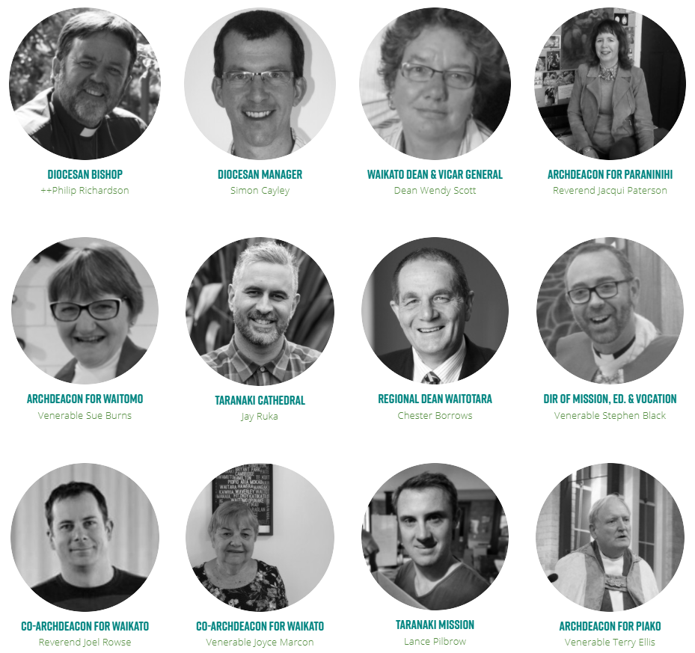

Communication

Diocesan
The primary platforms for diocesan communication are:
- The diocesan website: www.wtanglican.nz
- The diocesan e-newsletter: Connected (accessible from the website dropdown menu)
Please sign-up to Connected and check the website regularly to keep up with “Recent News and Updates” as well as “Events” – these are both featured on the homepage.
In addition, we have both a Facebook (https://www.facebook.com/wtanglican/) page and a YouTube Channel (https://www.youtube.com/channel/UCpi0Lrbf6LgHzzlPkPtbcvg).
To receive a simple introduction to the website, Youtube Channel and Facebook, please see here: https://www.wtanglican.nz/site_files/19978/upload_files/WTANGLICANWebsiteQuickguide.pdf?dl=1 or go to https://www.wtanglican.nz/page/admin/ and download the “Website Overview” at the top of the page.

Mission
Mission is the last instruction Jesus gave the disciples before he ascended to heaven. As Christians we are missionaries sent by God to represent Jesus. Being a missionary is not about doing things to people, but serving alongside people. Everyone who claims to be a disciple of Jesus Christ should also see themselves as a missionary. That’s because Jesus commissioned all believers to make disciples, to baptise, to teach the commandments, and to remember that He is always with us. So a missionary is not only someone who is called to work overseas - anyone of us can be a missionary in our local context.
To explore our diocesan approach to Mission please see: https://www.wtanglican.nz/mission/

Education and Formation
There are several events offered each year to support ongoing formation and education. To find out more about such opportunities please see here: https://www.wtanglican.nz/education/
Each year we generate an overview of all the training with a calendar. That’s available at the top of the web address listed above. If you require specific education or formation please be in touch with the Ministry Educator (stephen@wtanglican.nz).

Vocation
A vocation is a divine call inviting you to become the person God intends you to be. There are many different types of calling and we are called to many different things. When the Church talks about vocation it is concerned with a specific ministry within the Body of Christ. In the Anglican Church we believe that God loves all of us and has given each of us gifts to use in the Kingdom. God calls each of us to a ministry and it is the Church's role to help discern that calling and where possible nurture it. So, although a calling is a very personal invitation it is nevertheless a gift to the whole Body of Christ (the Church). It is important to remember that a vocation is not just about ordained or even licensed ministry. It is even more important to remember that because God loves and values each of us equally, one calling is no more important than another - what matters is discernment and your response. Don't be fooled into thinking that being a priest or deacon is the highest calling. It can be tempting to think that the closer you are to the altar the closer you are to God. In reality how close you are to God depends upon how much time you spend in prayer. There is simply no substitute for talking and listening to your Saviour. And that's where your vocation begins.
To explore our diocesan approach to Mission please see: https://www.wtanglican.nz/vocation/

Administration and Expectations
Sorry, administration simply cannot be avoided. The good news is that the diocesan office and its staff are eager to support you so that you can focus on your ministry.

Statutes
All diocesan statutes are updated online here: https://www.wtanglican.nz/administration-and-statutes/
We strongly recommend that you begin by reading the Statute of Pastors and the Parishes Statute. These will give you a solid understanding of how we approach ministry from a statutory perspective.

Clergy
As a clergy person you should have a covenant. This covenant will outline the key expectations associated with your role. This includes, but is not limited to:
- Regular supervision (at least six sessions per year): https://www.wtanglican.nz/clergy/
- Regular spiritual direction (at least six sessions per year): https://www.wtanglican.nz/clergy/
- Attendance at Bishop’s Training Days and possibly Deacons’ Training Days: https://www.wtanglican.nz/education/
- Ministry Standards training: https://www.wtanglican.nz/boundaries-courses/
- Synod: https://www.wtanglican.nz/synod/
- Te Huinga (ministry leadership conference - July): https://www.wtanglican.nz/the-gathering-te-huinga-clergy-conference/

Ministry Standards
The Anglican Church in Aotearoa New Zealand and Polynesia takes ministry standards very seriously. All licence holders are expected to receive regular supervision and spiritual direction as well as complete professional/ministry standards training.
It is essential that you complete the following two sessions and attain at least 80% in the related online quiz: https://www.wtanglican.nz/boundaries-courses/
- Ministry Standards One: Royal Commission and New Title D Canons
- Ministry Standards Two: Power in Ministry
It is also strongly recommended that you watch the introduction to boundaries in ministry course presented by Rev Sarah Park and produced by the Nelson Diocese:
https://www.wtanglican.nz/boundaries-courses/ The password for this video is “boundaries”.

Synod
All licenced clergy are required to attend Synod each year. In our Diocese we have a rhythm of two years of Synod in Hamilton and one year in Stratford. This meeting traditionally runs from a Friday night to a Sunday afternoon. Details of the Synod are posted online here: https://www.wtanglican.nz/synod/

Shared Life
We are the body of Christ; every one of us has been adopted into the family of God. Like any family we have challenges to overcome. As with any family, the more time we spend listening to one another, praying with one another, and sharing our lives with one another – the closer we become.
In the first instance, we ask you to commit to your ministry unit; to participate as best you can in rhythms of prayer, worship, and service. We hope that as you gather in the local you experience and contribute to the whole.
At the same time, you would be welcome to join us at morning prayer (Mon-Fri) on Zoom and also for Night Prayer on a Sunday at 7pm. The links for these prayers are at the top of the homepage.

Payroll, Pension scheme, Insurance and Moving Expenses
For initial information on payroll, please read your letter of offer. The terms and conditions, payment date, explanation of the Anglican Church Pension scheme and insurances and the transfer grant are all explained in this letter. For more detailed information about these topics, please contact the Executive Assistant at Charlotte Brown House.
For the relocation of your belongings, please also contact the Executive Assistant.

Contact Details
Bishop’s Office: bishopspa@wtanglican.nz
Vicar General: dean@stpeter.org.nz (Very Rev Wendy Scott – Waikato Cathedral)
Deputy Vicar General: jaqui.paterson@taranakicathedral.org.nz (Very Rev Jacqui Paterson – Taranaki Cathedral)
Manager: manager@wtanglican.nz (Simon Cayley)
Diocesan Director of Mission, Education and Formation: stephen@wtanglican.nz (Ven Stephen Black)
Executive Administrator: ea@wtanglican.nz (Jill Schumacher – Charlotte Brown House)
Diocesan Office: 07 857 0020

